Two flat ribbon cables, manufacture ERNI

Connectors and cables from ERNI

Header on board: <https://www.erni.com/en/products-and-solutions/detail/244856/>

Driver Board

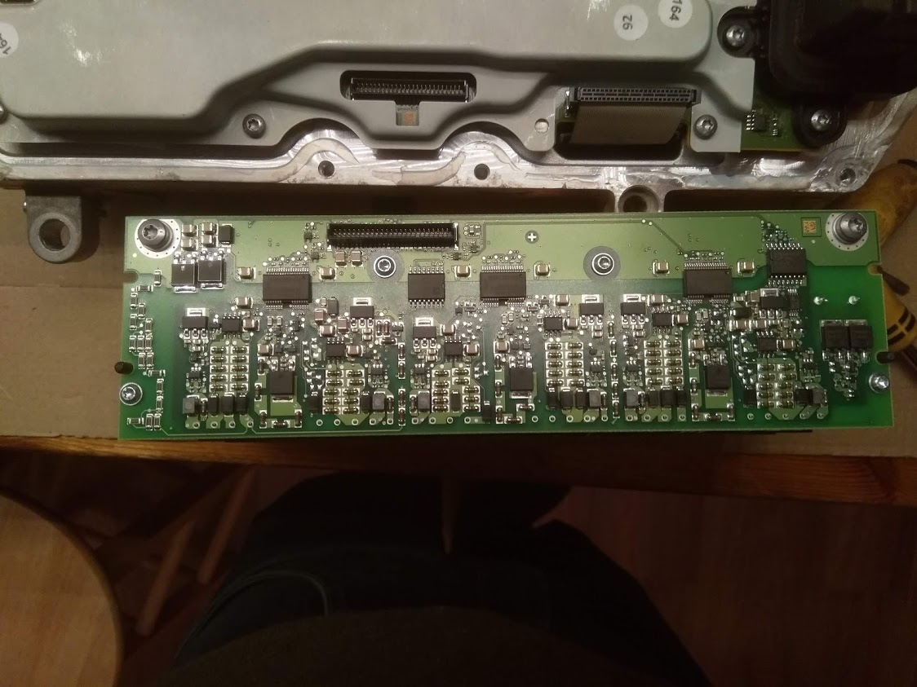

1 25

26 50

Three Dual Driver stages:

Main Chip: Infineon 2ED020I12FA

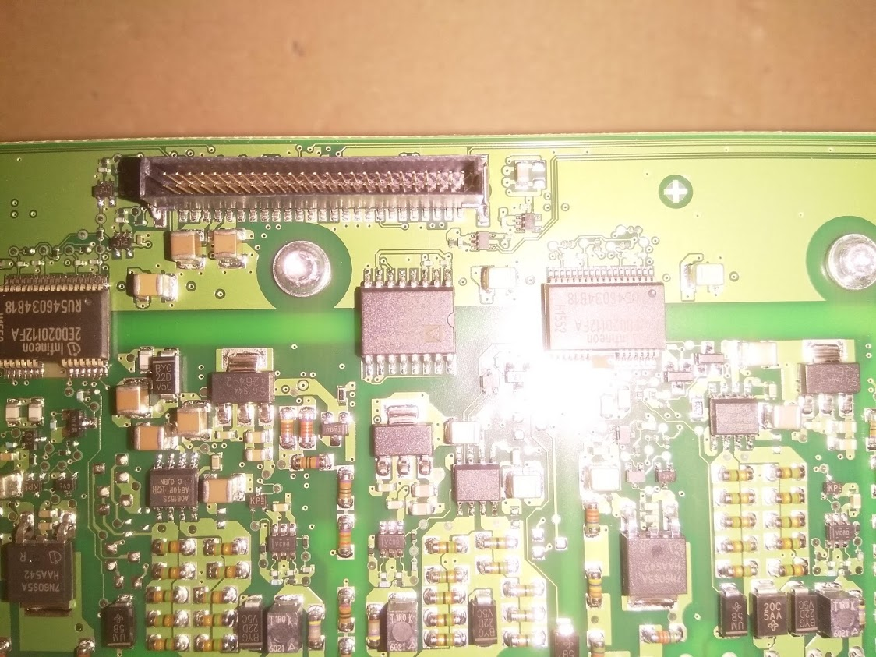

<https://www.infineon.com/dgdl/Infineon-2ED020I12FA-DS-v03_01-EN.pdf?fileId=db3a30432e779412012e7b87d2b23878>

Secondairy Chip: Analogue Devices UM1401W

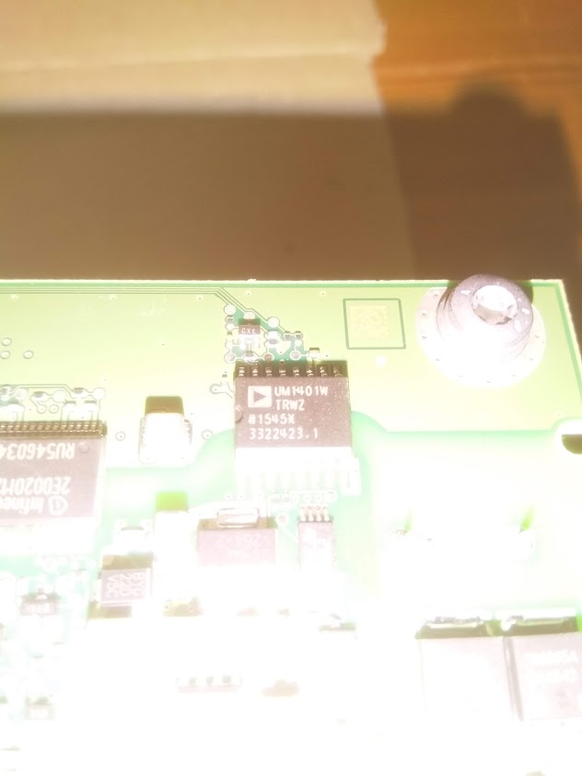

Quad Channel digital isolators

<https://www.analog.com/media/en/technical-documentation/data-sheets/adum1400_1401_1402.pdf>

Gate driver Infineon 2ED020I12FA:  
VCC1HS, VCC1LS Positive Supply 5 V power supply of the input chip

Output Stage

4264-2 :

<https://www.infineon.com/dgdl/Infineon-TLE4264-2G-DS-v02_60-EN.pdf?fileId=5546d46258fc0bc101595f6960991f2d>

SOP8 a08152s: AUIR08152S

<https://www.infineon.com/dgdl/auir08152s.pdf?fileId=5546d462533600a4015355a81616133a>

Input into mosfets and driver for Transformer supplies is +/-20V at 800Khz.

Temperature sensors

Each igbt has one 10K NTC

Shared ground, connected to Opto 2 ground